A Geometric Approach for Constructing Coteries and k-Coteries
Yu-Chen Kuo and Shing-Tsaan Huang
IEEE TRANSACTIONS ON PARREL AND DISTRIBUTED SYSTEMS, VOL. 8, NO. 4, APRIL 1997 pp.402-411
Abstract
In this paper, we introduce a geometric approach on dealing with the logical structures and present some useful geometric properties for constructing coteries and k-coteries. Based on those geometric properties, a logical structure named three-sided graph is proposed to provide a new scheme for constructing coteries with small quorums.
1.Introduction
- Geometric Properties
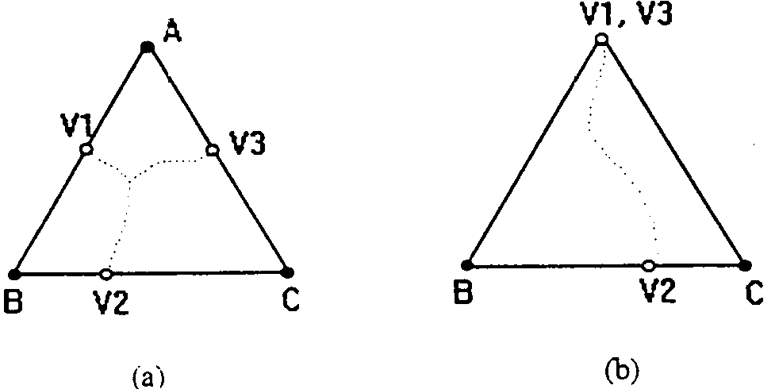
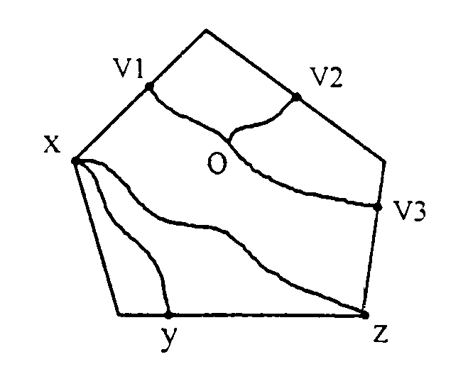
v₁o-v₂o-v₃o form a fork of the five-gon.

xy is a fork, too.

xz is not a fork.
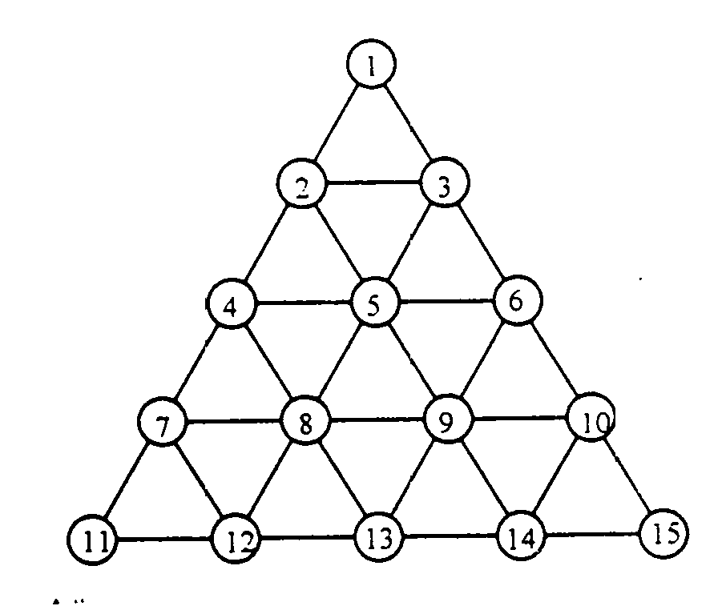
C={{1, 3, 6, 10, 15},
{1, 2, 5, 8, 13},
{2, 5, 8, 12},
{4, 5, 6, 8, 13}}
contains four members, each of which is a Y-quorum of the graph. It is easy to verify that those Y-quorums form a one-coterie.
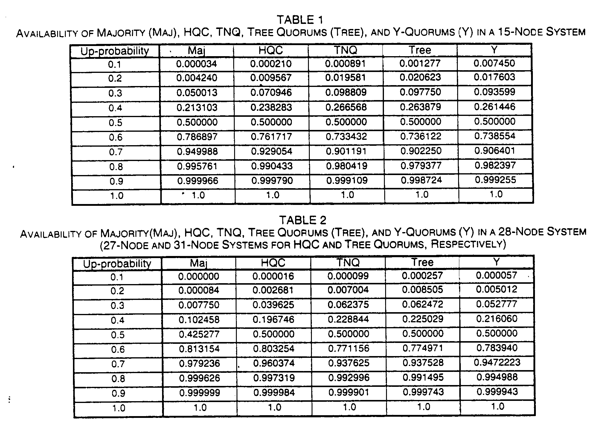
Created by : Kwo-Tsung Tseng
Date : Sept. 11, 1998

